NB Classwork

1. **Given the following dataset, apply the Naïve Bayes classifier to classify the new instance:**

(Color = Green, legs=2, Height=Tall, and Smelly=No) whether it belongs to species M or H.

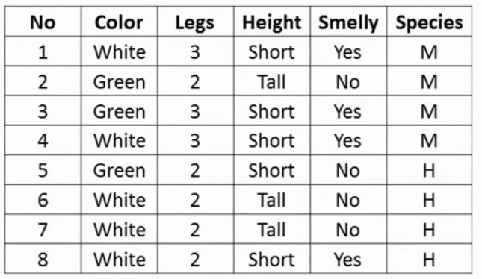

1. **Given the following dataset, apply the Naïve Bayes classifier to classify the new instance:**

(Temp=Cool, Humidity=High)

